Experiment -2
NAME: ROHITHNIETHAN ROLL NO:240701437

Design a UI where users recall visual elements .Evaluate the effect of chunking on user memory.
FRAME 1: INSTRUCTION PAGE:
Chunking Analysis of the Instruction Page
Chunking is a cognitive strategy that breaks down information into smaller, manageable units, making it easier to process and retain. The Memory Recall Task instruction page effectively utilizes chunking in the following ways:
- Clear and Sequential Numbering
• The instructions are broken down into six steps, making it easier to follow.
• Each step presents one key action in a structured manner, reducing cognitive overload.
- Logical Grouping of Information
• Observation Phase (Steps 1-2) → Users learn about what they will see.
• Memorization Strategy (Step 3) → Encourages users to focus on remembering items.
• Recall Phase (Steps 4-5) → Explains how users will recall information.
• Key Performance Metric (Step 6) → Highlights that accuracy matters more than speed.
- Visual Hierarchy and Design Elements
• Bold, large title ("MEMORY RECALL TASK") → Grabs attention and clearly states the task.
• Bullet points and spacing → Reduce clutter, enhancing readability.
• Highlighted "START" button → Signals the next step, keeping navigation intuitive.
• Bee-themed visuals → Add a playful touch, engaging users without distraction.
- Time Constraint Reinforcement
• Step 5 explicitly states, “You will have 5 seconds to view the items.”
• This reinforces expectations while subtly urging users to focus. 5. Simplicity and Clarity
• Instructions use short, direct sentences, avoiding unnecessary complexity.
• The active voice makes it more engaging and action-oriented.

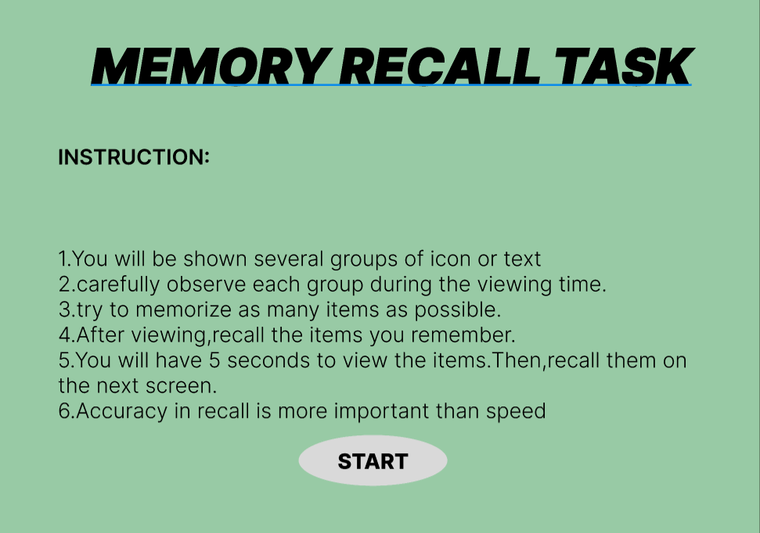

FRAME 2:
CHUNKING PHASE:
Analysis of the Memory Recall Task - Chunking Phase Screen This screen represents the Chunking Phase of a Memory Recall Task, where users observe and memorize different icons within a limited time. Below is a breakdown of its key components: 1. 1.Purpose of the Screen
• This is the visual memory encoding phase, where users view and group items mentally before recalling them.
• The term "Chunking Phase" suggests that the game applies the chunking principle, which helps users remember items by categorizing them into meaningful groups.
2. Key Elements and UI Components Countdown Timer (Top Left - Red Circle: "00:05")
• Indicates that users have 5 seconds to observe and memorize the displayed items.
• The bright red color and bold text create urgency, ensuring users stay focused. Progress Bar
• Shows the time remaining visually, reinforcing the sense of urgency.
• A partially filled bar suggests that some time has already passed. Grid of Icons
• Various icons (such as a pig, burger, clock, police car, arrow, snowman, bee, laughing emoji, etc.) are displayed in a 5x4 grid format.
• These icons are visually distinct yet grouped by similarities, encouraging chunking strategies like: Categorizing by theme (e.g., animals, food, transportation). Grouping similar colors or backgrounds (e.g., pink, blue, or yellow tiles). Associating repeated icons (e.g., multiple bees, burgers, police cars). Bee Character Holding a Scroll
• Acts as a friendly mascot, enhancing engagement and giving a playful theme.
• The scroll may imply instructions or guidance in later stages.
3. How the Chunking Phase Works
1. Users scan the grid and look for patterns or related items to create mental chunks.
2. The countdown timer limits observation time, forcing quick memory strategies.
3. Once time is up, users transition to the recall phase, where they must identify previouslyseen items.
4. Cognitive and UX Benefits of Chunking
• Enhances short-term memory by allowing users to recall groups of information instead of individual elements.
• Reduces cognitive overload by helping users organize data efficiently.
• Improves pattern recognition, making recall easier and more accurate.
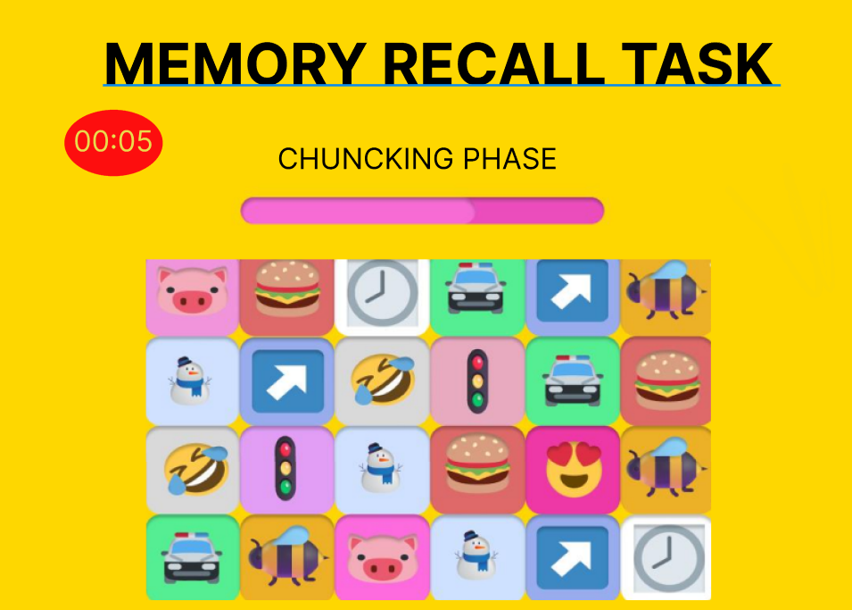
FRAME 3:
RECALL PHASE:
Analysis of the Memory Recall Task - Selection Phase This screen represents the Selection Phase of a Memory Recall Task, where users recall and choose the items they remember from the previous Chunking Phase. Below is a breakdown of its components: 1. Purpose of the Screen
• This is the memory retrieval stage, where users select the items they remember seeing in the previous phase.
• The goal is to test the effectiveness of chunking and short-term memory retention.
2. Key Elements and UI Components Title & Instructions
• "MEMORY RECALL TASK" (Bold Header) – Reinforces the purpose of the task.
• "SELECT THE ITEMS YOU REMEMBER:" – Clear instruction guiding the user to choose remembered items.
Grid of Icon Choices
• A set of eight icons are presented as multiple-choice options.
• Some icons were previously displayed, while others are distractors (new icons added to confuse users).
• Users must identify which icons appeared in the Chunking Phase.
• Each icon has a radio button below it for selection. Animated Bee Character
• The bee character reinforces a playful, engaging theme.
• It may act as a mascot or guide throughout the memory task. "SUBMIT" Button
• Once users have made their selections, they press "SUBMIT" to confirm their recall choices.
3. How the Selection Phase Works
1. Users analyze the displayed icons and recall which ones they saw in the Chunking Phase.
2. They select the remembered icons using the radio buttons below each option.
3. Some icons are distractors, testing whether the user’s memory is accurate or if they mistakenly recall incorrect icons.
4. Clicking "SUBMIT" finalizes their choices, leading to a results or feedback screen.
4. Cognitive and UX Benefits
• Tests memory accuracy by comparing user selections with previously displayed items.
• Incorporates distractors to evaluate how well users distinguish real vs. false memories.
• User-friendly interface with clear selection mechanics . Grid of Icon Choices
• A set of eight icons are presented as multiple-choice options.
• Some icons were previously displayed, while others are distractors .
• Users must identify which icons appeared in the Chunking Phase.
• Gamified elements (bee character, bright colors) make the task engaging.

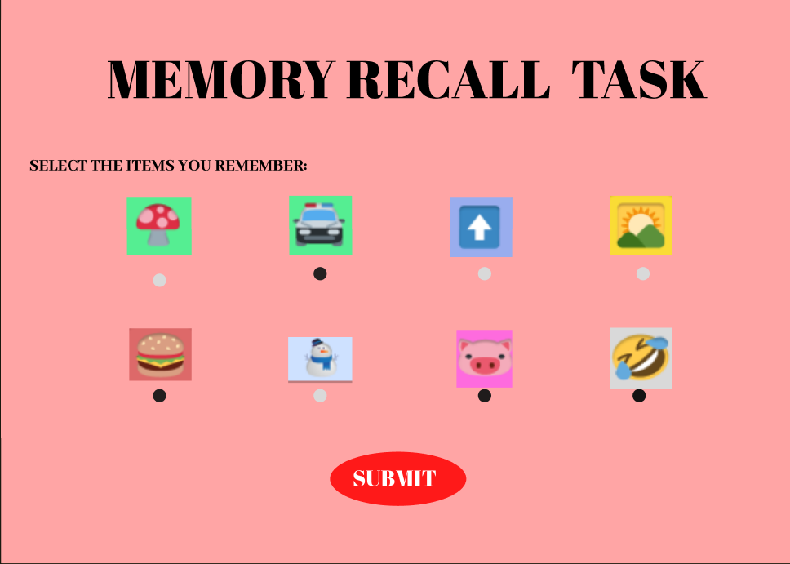FRAME 4:
RESULT PAGE:
Analysis of the Memory Recall Task - Score & Feedback Screen This screen represents the Score & Feedback Phase of the Memory Recall Task, where users receive their performance evaluation based on the selections made in the previous Recall Phase.
- Purpose of the Screen
• Provides feedback on recall accuracy by showing the number of correct answers.
• Allows users to decide their next action (continue, restart, or exit).
2.Key Elements & UI Components Title & Score Display
•"MEMORY RECALTASK" – Reinforces the game’s title.
• "YOUR RECALL SCORE!" – Indicates that the user’s performance is being displayed.
• A wooden scoreboard with the user’s score (4/5) in bold, showing correct answers out of total attempts. Action Buttons (Right Side)
1. "CONTINUE" – Proceeds to the next level or stage.
2. "RESTART" – Allows the user to retake the memory recall test

3."EXIT" – Ends the task and exits the game. Animated Bee Character . The bee character adds a playful, gamified element
. • Holds a blank sign, possibly for dynamic messages or additional instructions.
3. How This Phase Works
1. The game evaluates the user’s selections from the Recall Phase
. 2. It calculates the accuracy score (4/5 in this case) and displays it on a wooden board.
3. Users review their performance and choose their next action: Continue if they want to proceed. Restart if they want to improve their recall. Exit if they want to stop playing.
4. Cognitive & UX Benefits
• Instant feedback helps users track their memory performance.
• Multiple options (Continue, Restart, Exit) give users control over their learning experience.
• Visual & gamified elements make the task engaging and less stressful.
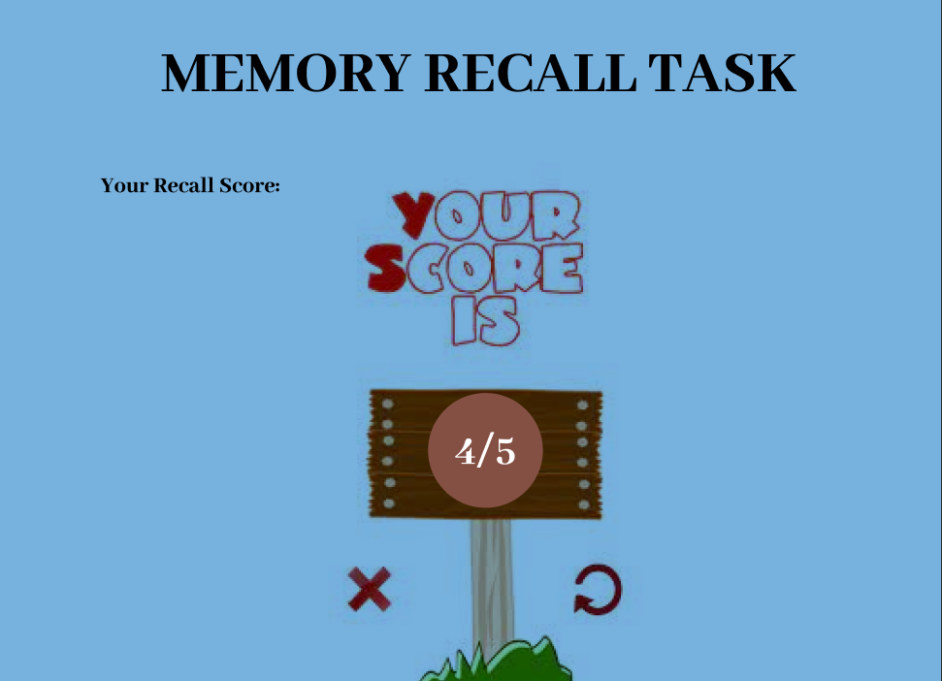
PROTOTYPE LINK: https://www.figma.com/design/O3u1T96VhHDpQeocKxzUqC/Untitled?node-id=0-1&t=fg4sWyNpoqGKJRSc-1

